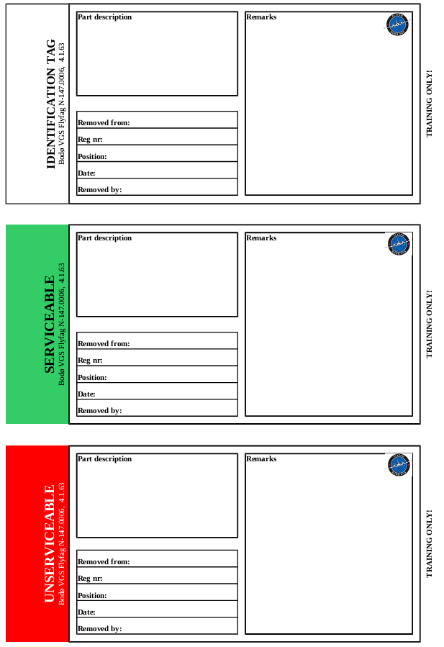

**Interne referanser**

|  |  |
| --- | --- |
|  |  |

**Eksterne referanser**

|  |
| --- |
|  |